Tapestry Demonstration Fund
Institutional Performance Tear Sheet

Return Analytics
Metric | Fund | S&P 500 | MSCI ACWI | Russell 2000
Annualized Return Since Inception | 17.64% | 15.54% | 14.15% | 10.55%
Inception to Date Return | 187.47% | 155.66% | 136.43% | 91.91%
2020 Return | 21.36% | 18.40% | 16.54% | 19.93%
2021 Return | 18.52% | 28.70% | 22.40% | 14.78%
2022 Return | -3.99% | -18.13% | -17.70% | -20.46%
2023 Return | 8.33% | 26.23% | 24.47% | 16.88%
2024 Return | 28.58% | 25.01% | 19.23% | 11.52%
2025 Return | 21.84% | 17.85% | 21.63% | 12.79%
2026 YTD Return | 22.67% | 10.19% | 11.56% | 19.21%
Annualized Return Last 3 Years | 27.19% | 20.59% | 20.37% | 17.49%
Annualized Return Last 1 Year | 21.28% | 22.30% | 23.62% | 36.92%
Best Month Return | 12.17% | 12.82% | 12.83% | 18.42%
Worst Month Return | -6.50% | -12.35% | -13.17% | -21.73%

AI Commentary:
Since inception, Tapestry Demonstration Fund has compounded at 17.64% annualized versus 15.54% for the S&P 500 and 14.15% for MSCI ACWI, translating into a higher cumulative outcome (187.47% vs. 155.66% and 136.43%, respectively). The magnitude of the excess is meaningful but not extreme, which matters for allocators assessing whether the return profile can plausibly be explained by modest factor tilts versus persistent security selection or structural edge. The fund’s edge is more notable versus Russell 2000 (10.55% annualized; 91.91% cumulative), suggesting either a preference away from small-cap beta, better downside control during small-cap stress regimes, or differentiated exposure set that avoided the weakest segments of that benchmark.
The year-by-year pattern indicates a return stream that is not simply “index-like.” In 2021 the fund lagged the S&P 500 materially (18.52% vs. 28.70%), and in 2023 it lagged again (8.33% vs. 26.23%), consistent with a lower-beta posture and/or a portfolio that did not fully participate in sharp, index-led risk-on rallies. By contrast, 2022 is a differentiator: the fund was down only -3.99% versus -18.13% for the S&P 500 and -17.70% for ACWI, indicating meaningful defensive characteristics when broad equities were under pressure. In 2024 and 2025 the fund delivered strong absolute results (28.58% and 21.84%) and outperformed the S&P 500 in both years, suggesting the profile is not purely capital-preservation oriented and can still monetize constructive markets, albeit not always at full market pace.
Recent momentum appears favorable with 2026 YTD at 22.67% versus 10.19% for the S&P 500 and 11.56% for ACWI, and the last 3 years annualized at 27.19% versus 20.59% for the S&P 500. However, last 1-year performance slightly trails large-cap equities (21.28% vs. 22.30% S&P 500) and materially trails Russell 2000 (36.92%), reinforcing that relative outcomes can vary considerably depending on which equity segment leads. Allocators should interpret the return profile as “equity-plus with dampened market linkage” rather than a consistent index-beater in every up tape, and should diligence what explicit exposures (sector, factor, net/gross, hedges) drive periods of lag versus the S&P 500 during strong momentum regimes.
Definitions and Interpretation
Annualized Return Since Inception
Definition: Measures the compound annual growth rate of the return stream from inception through the latest period.
Why It Matters: Shows the long-term annualized return generated by the strategy.
Allocator Interpretation: Higher annualized return versus benchmarks may indicate stronger long-term compounding.
Inception to Date Return
Definition: Measures the total cumulative return from the beginning of the track record through the latest available month.
Why It Matters: Shows the actual total compounded gain or loss over the full measurement period, without annualizing the result.
Allocator Interpretation: A strong inception-to-date return provides a clear view of total wealth creation over the full track record and should be reviewed alongside annualized return, volatility, and drawdown.
2020 Return
Definition: Measures the cumulative return for the specified calendar year or year-to-date period.
Why It Matters: Calendar-year returns help investors see how performance was generated across different market environments rather than only over trailing periods.
Allocator Interpretation: Consistent calendar-year performance versus benchmarks may indicate durability, while large differences by year can highlight market sensitivity, factor exposure, or strategy-specific return drivers.
2021 Return
Definition: Measures the cumulative return for the specified calendar year or year-to-date period.
Why It Matters: Calendar-year returns help investors see how performance was generated across different market environments rather than only over trailing periods.
Allocator Interpretation: Consistent calendar-year performance versus benchmarks may indicate durability, while large differences by year can highlight market sensitivity, factor exposure, or strategy-specific return drivers.
2022 Return
Definition: Measures the cumulative return for the specified calendar year or year-to-date period.
Why It Matters: Calendar-year returns help investors see how performance was generated across different market environments rather than only over trailing periods.
Allocator Interpretation: Consistent calendar-year performance versus benchmarks may indicate durability, while large differences by year can highlight market sensitivity, factor exposure, or strategy-specific return drivers.
2023 Return
Definition: Measures the cumulative return for the specified calendar year or year-to-date period.
Why It Matters: Calendar-year returns help investors see how performance was generated across different market environments rather than only over trailing periods.
Allocator Interpretation: Consistent calendar-year performance versus benchmarks may indicate durability, while large differences by year can highlight market sensitivity, factor exposure, or strategy-specific return drivers.
2024 Return
Definition: Measures the cumulative return for the specified calendar year or year-to-date period.
Why It Matters: Calendar-year returns help investors see how performance was generated across different market environments rather than only over trailing periods.
Allocator Interpretation: Consistent calendar-year performance versus benchmarks may indicate durability, while large differences by year can highlight market sensitivity, factor exposure, or strategy-specific return drivers.
2025 Return
Definition: Measures the cumulative return for the specified calendar year or year-to-date period.
Why It Matters: Calendar-year returns help investors see how performance was generated across different market environments rather than only over trailing periods.
Allocator Interpretation: Consistent calendar-year performance versus benchmarks may indicate durability, while large differences by year can highlight market sensitivity, factor exposure, or strategy-specific return drivers.
2026 YTD Return
Definition: Measures the cumulative return for the specified calendar year or year-to-date period.
Why It Matters: Calendar-year returns help investors see how performance was generated across different market environments rather than only over trailing periods.
Allocator Interpretation: Consistent calendar-year performance versus benchmarks may indicate durability, while large differences by year can highlight market sensitivity, factor exposure, or strategy-specific return drivers.
Annualized Return Last 3 Years
Definition: Measures the compound annual return over the most recent 36 months.
Why It Matters: Helps evaluate recent medium-term performance.
Allocator Interpretation: Outperformance over this period may suggest the strategy has remained effective in the recent market environment.
Annualized Return Last 1 Year
Definition: Measures the compound return over the most recent 12 months.
Why It Matters: Highlights the most recent trailing-year performance.
Allocator Interpretation: Strong or weak one-year results should be reviewed alongside longer-term returns and risk measures.
Best Month Return
Definition: Identifies the highest monthly return in the track record.
Why It Matters: Shows the Fund’s strongest upside month.
Allocator Interpretation: A strong best month may indicate upside capture, but should be evaluated with volatility and drawdown.
Worst Month Return
Definition: Identifies the lowest monthly return in the track record.
Why It Matters: Shows the Fund’s worst single-month loss.
Allocator Interpretation: A smaller worst month than benchmarks may suggest better downside control.

Best / Worst Periods
Metric | Fund | S&P 500 | MSCI ACWI | Russell 2000
Best Month Return | 12.17% | 12.82% | 12.83% | 18.42%
Best Month Date | Nov-24 | Apr-20 | Nov-20 | Nov-20
Worst Month Return | -6.50% | -12.35% | -13.17% | -21.73%
Worst Month Date | Mar-20 | Mar-20 | Mar-20 | Mar-20

AI Commentary:
The fund’s best month was +12.17% (Nov-24), which is competitive with global equities but modestly below the best single-month outcomes seen in the benchmarks (e.g., Russell 2000 +18.42%). This can be read as a return distribution that is less reliant on very large upside months to generate attractive long-run compounding. For allocators, that shape often aligns with repeatability and a process that is not implicitly “long optionality” or highly levered to sharp rebounds, though it can also imply under-participation when markets melt up.
The worst month was -6.50% (Mar-20), substantially better than the S&P 500’s -12.35% and ACWI’s -13.17% in the same stress period, and far better than Russell 2000’s -21.73%. That relative resilience in the canonical liquidity shock is an important signal: it suggests either lower gross risk, exposure choices that were less pro-cyclical, more effective hedging, or better liquidity management that avoided forced de-risking. From an allocator perspective, this is often more decision-relevant than the best month, because it speaks to behavioral stickiness of capital and the ability to remain invested through system-level drawdowns.
The pairing of a relatively contained worst month with a still-strong best month indicates the fund’s path to returns likely emphasizes limiting left-tail outcomes rather than maximizing convex right-tail payoffs. A key diligence question is whether this downside containment is structural (e.g., risk limits, hedges, diversification, net exposure management) or was period-specific. Allocators should also test whether the same downside behavior persists in non-equity stress events (rates shocks, commodity spikes, vol regime shifts), since March 2020 is a singular event and can sometimes overstate the durability of a defensive toolkit.
Definitions and Interpretation
Best Month Return
Definition: Identifies the highest monthly return in the track record.
Why It Matters: Shows the Fund’s strongest upside month.
Allocator Interpretation: A strong best month may indicate upside capture, but should be evaluated with volatility and drawdown.
Best Month Date
Definition: Identifies the month in which the best monthly return occurred.
Why It Matters: Provides market-period context for the strongest return.
Allocator Interpretation: Useful for understanding whether upside came during broad market strength or fund-specific conditions.
Worst Month Return
Definition: Identifies the lowest monthly return in the track record.
Why It Matters: Shows the Fund’s worst single-month loss.
Allocator Interpretation: A smaller worst month than benchmarks may suggest better downside control.
Worst Month Date
Definition: Identifies the month in which the worst monthly return occurred.
Why It Matters: Provides market-period context for the largest loss.
Allocator Interpretation: Useful for assessing how the Fund behaved during stressed or unfavorable markets.

Volatility & Risk
Metric | Fund | S&P 500 | MSCI ACWI | Russell 2000
Annualized Volatility | 13.00% | 17.16% | 16.75% | 22.99%
Annualized Gain Volatility | 9.46% | 10.05% | 9.64% | 14.55%
Annualized Loss Volatility | 6.71% | 10.85% | 10.68% | 14.41%
Annualized Downside Volatility | 6.45% | 10.51% | 10.56% | 14.72%
Maximum Drawdown | -8.74% | -23.88% | -25.10% | -28.32%
Recovery Time / Drawdown Duration | 22 | 23 | 23 | 36

AI Commentary:
The fund exhibits meaningfully lower total volatility (13.00%) than the S&P 500 (17.16%) and ACWI (16.75%), with an even larger gap versus Russell 2000 (22.99%). The decomposition is notable: loss volatility (6.71%) and downside volatility (6.45%) are substantially below the benchmarks’ roughly 10–11% levels, indicating that risk reduction is coming disproportionately from dampening negative-return dispersion rather than merely smoothing upside. For allocators, this profile can be attractive in multi-asset or equity-completion roles where the objective is to maintain equity participation while reducing drawdown depth and behavioral risk.
Maximum drawdown is contained at -8.74%, dramatically less than -23.88% for the S&P 500 and -25.10% for ACWI. This is a defining attribute of the fund’s risk profile and, if repeatable, can materially improve portfolio-level outcomes via less capital impairment and less time “digging out” from losses. The reported recovery time/drawdown duration of 22 (vs. 23 for the S&P 500 and ACWI, and 36 for Russell 2000) suggests that while the fund falls less, it still experiences drawdown episodes of comparable length to large-cap equities—an important nuance for allocators who equate “smaller drawdown” with “faster recovery.” In other words, the depth is improved more than the duration.
A reasonable interpretation is that the fund behaves like a lower-beta equity strategy with some diversification or explicit risk controls, but not a pure crisis alpha profile that instantly rebounds. Allocators should diligence how risk is produced: whether volatility is structurally capped through net exposure, position sizing, sector constraints, or hedges; and whether lower volatility is achieved at the cost of crowding into lower-volatility equity factors that can underperform in sharp risk-on rallies. Scenario analysis across 2021 and 2023-type momentum surges versus 2022-type selloffs is particularly relevant to understand the “price” paid for drawdown containment.
Definitions and Interpretation
Annualized Volatility
Definition: Measures the annualized standard deviation of monthly returns.
Why It Matters: Common measure of total return variability.
Allocator Interpretation: Lower volatility with competitive returns may indicate better risk efficiency.
Annualized Gain Volatility
Definition: Measures the annualized volatility of positive monthly returns.
Why It Matters: Shows variability during winning months.
Allocator Interpretation: Can help distinguish consistent upside from uneven or lumpy gains.
Annualized Loss Volatility
Definition: Measures the annualized volatility of negative monthly returns.
Why It Matters: Shows variability during losing months.
Allocator Interpretation: Lower loss volatility may suggest more controlled downside behavior.
Annualized Downside Volatility
Definition: Measures annualized volatility of returns below the downside threshold.
Why It Matters: Focuses specifically on harmful volatility rather than total volatility.
Allocator Interpretation: Lower downside volatility is generally favorable for hedged and absolute-return strategies.
Maximum Drawdown
Definition: Measures the largest peak-to-trough decline over the period.
Why It Matters: One of the most important capital preservation measures.
Allocator Interpretation: A smaller drawdown than benchmarks may indicate stronger downside protection.
Recovery Time / Drawdown Duration
Definition: Measures the longest period spent below a prior high watermark.
Why It Matters: Shows how long investors may have had to wait for recovery.
Allocator Interpretation: Shorter recovery periods are generally viewed favorably by institutional investors.

Distribution Analytics
Metric | Fund | S&P 500 | MSCI ACWI | Russell 2000
Skewness | 0.31 | -0.33 | -0.41 | -0.23
Excess Kurtosis | 0.44 | 0.12 | 0.46 | 0.96
Average Monthly Gain | 3.41% | 4.28% | 3.96% | 5.23%
Average Monthly Loss | -2.53% | -3.94% | -4.25% | -5.27%
Gain/Loss Ratio | 1.35 | 1.09 | 0.93 | 0.99
Positive Months Fraction | 66.67% | 64.10% | 66.67% | 60.26%
Negative Months Fraction | 33.33% | 35.90% | 33.33% | 39.74%

AI Commentary:
The return distribution shows positive skewness (0.31) versus negative skew in the benchmarks (S&P 500 -0.33; ACWI -0.41), indicating the fund has tended to experience relatively more upside surprise than downside shock compared with traditional equities. Excess kurtosis (0.44) is modest—higher than the S&P 500 but in line with ACWI—suggesting some fat-tailed behavior but not an extreme tail-risk profile. For allocators, positive skew coupled with moderate kurtosis is generally favorable, but it warrants attribution work: strategies can generate positive skew either through optionality/convexity (which can be costly) or through effective loss mitigation and opportunistic re-risking (which can be process-driven).
Average monthly losses are materially smaller (-2.53%) than those of the benchmarks (approximately -3.94% to -5.27%), while average monthly gains (3.41%) are somewhat lower than the equity indices shown. The resulting gain/loss ratio of 1.35 exceeds all benchmarks listed (S&P 500 1.09; ACWI 0.93; Russell 2000 0.99), implying the fund’s compounding is supported by better asymmetry rather than simply higher hit rate. The positive month fraction (66.67%) is comparable to ACWI and slightly above the S&P 500, suggesting that the fund is not relying on rare outlier months to do the heavy lifting; instead, it is producing a reasonably consistent positive month cadence.
From a diligence standpoint, the combination of smaller down months, positive skew, and a higher gain/loss ratio often points to a disciplined risk process, but allocators should verify whether this distribution is stable across regimes or dependent on a subset of periods (e.g., 2022 and 2024–2026). It is also important to assess whether smoothing is a byproduct of holdings’ liquidity and pricing, particularly if the strategy includes less frequently traded instruments. While nothing here indicates an obvious red flag, allocators should still review valuation policies (if applicable), position liquidity, and any use of derivatives that could alter realized distribution characteristics in stressed markets.
Definitions and Interpretation
Skewness
Definition: Measures asymmetry in the return distribution.
Why It Matters: Positive skew suggests larger upside outliers; negative skew suggests larger downside outliers.
Allocator Interpretation: Positive skew is generally attractive because it may indicate favorable return asymmetry.
Excess Kurtosis
Definition: Measures the degree of tail heaviness relative to a normal distribution.
Why It Matters: Helps evaluate whether returns have unusually large outlier events.
Allocator Interpretation: Higher kurtosis may indicate greater tail risk or more extreme return events.
Average Monthly Gain
Definition: Measures the average return during positive months.
Why It Matters: Shows the typical magnitude of winning months.
Allocator Interpretation: Larger average gains relative to losses may support a favorable payoff profile.
Average Monthly Loss
Definition: Measures the average return during negative months.
Why It Matters: Shows the typical magnitude of losing months.
Allocator Interpretation: Smaller average losses may indicate downside discipline.
Gain/Loss Ratio
Definition: Compares average monthly gains to average monthly losses.
Why It Matters: Shows whether winning months tend to outweigh losing months.
Allocator Interpretation: A ratio above 1.0 generally indicates average gains exceed average losses.
Positive Months Fraction
Definition: Measures the percentage of months with positive returns.
Why It Matters: Shows consistency of positive monthly performance.
Allocator Interpretation: A higher positive month fraction can indicate more consistent performance.
Negative Months Fraction
Definition: Measures the percentage of months with negative returns.
Why It Matters: Shows frequency of losing months.
Allocator Interpretation: A lower negative month fraction may indicate greater return consistency.

Risk-Adjusted Returns
Metric | Fund | S&P 500 | MSCI ACWI | Russell 2000
Sharpe Ratio | 1.09 | 0.76 | 0.70 | 0.42
Sortino Ratio | 2.11 | 1.20 | 1.10 | 0.67
Omega Ratio | 2.55 | 1.87 | 1.79 | 1.46
Calmar Ratio | 2.02 | 0.65 | 0.56 | 0.37

AI Commentary:
The fund’s Sharpe ratio of 1.09 compares favorably to the S&P 500 (0.76) and ACWI (0.70), reflecting that the strategy has delivered higher return per unit of total risk over the sample. The Sortino ratio is even more differentiated at 2.11 versus 1.20 (S&P 500) and 1.10 (ACWI), consistent with the earlier observation that downside volatility is where the fund distinguishes itself. For allocators, this combination typically signals that the strategy’s risk budgeting is oriented toward minimizing harmful variance rather than optimizing headline volatility alone.
The Omega ratio of 2.55 further supports an attractive balance of gains versus losses across the distribution, and the Calmar ratio of 2.02 is particularly noteworthy given the low maximum drawdown (-8.74%). Compared with the S&P 500’s Calmar of 0.65 and ACWI’s 0.56, the fund’s drawdown-adjusted efficiency is a key strength and aligns with a role as a smoother equity allocation or diversifying growth sleeve. That said, Calmar can look structurally strong for any strategy that successfully avoided one major drawdown period; allocators should be cautious about over-extrapolating without understanding how the strategy would behave in alternative stress types (e.g., inflation shocks, rapid rate cuts/rises, volatility spikes without equity drawdowns).
A potential weakness embedded in these strong risk-adjusted metrics is the possibility of systematic under-capture in strong equity rallies, which can be acceptable if it is compensated by meaningful drawdown protection and low correlation, but challenging if clients anchor to benchmark-relative returns over shorter horizons. Therefore, allocator evaluation should emphasize consistency of the risk control framework, governance around exposure adjustments, and whether the strategy’s defensive posture is intentional and repeatable rather than incidental. Understanding how the manager calibrates risk when volatility is falling (when many strategies inadvertently increase beta) is especially important in sustaining these ratios through a full cycle.
Definitions and Interpretation
Sharpe Ratio
Definition: Measures excess return per unit of total volatility.
Why It Matters: Shows whether returns were efficient relative to total risk.
Allocator Interpretation: A higher Sharpe Ratio than benchmarks suggests stronger risk-adjusted performance.
Sortino Ratio
Definition: Measures excess return per unit of downside volatility.
Why It Matters: Focuses on downside risk rather than all volatility.
Allocator Interpretation: A higher Sortino Ratio suggests better downside-adjusted performance.
Omega Ratio
Definition: Compares gains above a threshold to losses below that threshold.
Why It Matters: Captures both upside and downside behavior around a hurdle rate.
Allocator Interpretation: An Omega Ratio above 1.0 indicates gains exceeded losses relative to the selected threshold.
Calmar Ratio
Definition: Measures annualized return divided by absolute maximum drawdown.
Why It Matters: Evaluates return generation relative to drawdown risk.
Allocator Interpretation: A higher Calmar Ratio indicates stronger return generation per unit of drawdown.

Benchmark Relative Analytics
Metric | Fund vs S&P 500 | Fund vs MSCI ACWI | Fund vs Russell 2000
Excess Return | 2.10% | 3.49% | 7.09%
Up Capture Ratio | 60.89% | 64.17% | 51.89%
Down Capture Ratio | 17.01% | 18.61% | 9.77%
Up Number Ratio | 80.00% | 80.77% | 78.72%
Down Number Ratio | 57.14% | 61.54% | 51.61%
Up Percentage Ratio | 60.89% | 64.17% | 51.89%
Down Percentage Ratio | 17.01% | 18.61% | 9.77%
Correlation | 55.02% | 50.81% | 51.70%
Upside Correlation | 32.57% | 31.02% | 27.24%
Downside Correlation | 52.00% | 33.56% | 42.80%
Annualized Alpha | 8.76% | 9.56% | 11.34%
Beta | 0.42 | 0.39 | 0.29
R-Squared | 30.27% | 25.82% | 26.73%
Annualized Tracking Error | 14.77% | 15.11% | 19.71%
Information Ratio | 0.08 | 0.16 | 0.23
Batting Average | 46.15% | 48.72% | 52.56%
Treynor Ratio | 0.34 | 0.36 | 0.48

AI Commentary:
Relative to the S&P 500 and ACWI, the fund has generated modest excess return (2.10% and 3.49%, respectively) while exhibiting low beta (0.42 vs S&P 500; 0.39 vs ACWI) and low-to-moderate correlation (55% vs S&P 500; 51% vs ACWI). The low R-squared (30% and 26%) indicates that a majority of return variance is not explained by these equity benchmarks, which can be valuable to allocators seeking diversification within a growth allocation. However, it also means that benchmark-relative outcomes may be noisy, and conventional expectations about “keeping up” with equity rallies may not always hold.
Capture ratios underline the asymmetric participation: up capture is meaningfully below 100% (about 61–64% vs S&P 500/ACWI), while down capture is very low (17–19%). This is consistent with a strategy that sacrifices some upside participation to materially reduce losses in down markets, which can improve compounded outcomes and reduce portfolio drawdowns. The upside correlation is particularly low (about 33% vs S&P 500; 31% vs ACWI), suggesting that when markets rise, the fund’s return drivers are only loosely aligned with benchmark upside—helpful for diversification, but potentially frustrating for allocators expecting tight participation in bull runs. Conversely, downside correlation is higher versus the S&P 500 (52%) than versus ACWI (34%), implying the fund may still be influenced by U.S. equity stress dynamics even if magnitude is dampened.
The fund reports strong annualized alpha (8.76% vs S&P 500; 9.56% vs ACWI) alongside low beta, which, if robust, is an attractive profile. Yet several relative-performance diagnostics advise caution in interpretation: tracking error is high (14.77–15.11%), while information ratios are low (0.08–0.16) and batting average is below 50% versus large-cap/global benchmarks. In allocator terms, this looks like a strategy with meaningful differentiation and potential idiosyncratic return sources, but with excess returns that may be episodic rather than consistently delivered in most periods. Diligence should therefore focus on identifying the underlying alpha drivers, assessing capacity and crowding risk, and confirming that the low-beta/low-down-capture characteristics are a deliberate design choice supported by repeatable implementation rather than an artifact of the sample period.
Definitions and Interpretation
Excess Return
Definition: Measures Fund annualized return minus benchmark annualized return.
Why It Matters: Shows absolute outperformance or underperformance versus a benchmark.
Allocator Interpretation: Positive excess return indicates the Fund outperformed the benchmark over the period.
Up Capture Ratio
Definition: Measures Fund performance during positive benchmark months relative to benchmark performance.
Why It Matters: Shows upside participation.
Allocator Interpretation: Lower up capture may be acceptable for hedged strategies if downside capture is also low.
Down Capture Ratio
Definition: Measures Fund performance during negative benchmark months relative to benchmark performance.
Why It Matters: Shows downside participation.
Allocator Interpretation: Lower down capture is generally favorable and indicates downside protection.
Up Number Ratio
Definition: Measures how often the Fund was positive when the benchmark was positive.
Why It Matters: Shows consistency during positive benchmark months.
Allocator Interpretation: A higher ratio indicates the Fund more frequently participated in up markets.
Down Number Ratio
Definition: Measures how often the Fund was negative when the benchmark was negative.
Why It Matters: Shows how often the Fund declined during benchmark down months.
Allocator Interpretation: A lower ratio suggests the Fund avoided losses more often during weak benchmark periods.
Up Percentage Ratio
Definition: Compares total Fund gains during positive benchmark months to total benchmark gains during those same months.
Why It Matters: Shows cumulative upside participation during favorable benchmark environments.
Allocator Interpretation: Lower up percentage capture may be acceptable for hedged strategies when paired with substantially lower downside capture.
Down Percentage Ratio
Definition: Compares total Fund losses during negative benchmark months to total benchmark losses during those same months.
Why It Matters: Shows cumulative downside participation during unfavorable benchmark environments.
Allocator Interpretation: Lower down percentage capture is generally favorable and may indicate effective downside protection.
Correlation
Definition: Measures the degree to which Fund returns move with benchmark returns.
Why It Matters: Helps determine whether the strategy behaves like the benchmark or provides diversification.
Allocator Interpretation: Lower correlation may suggest the Fund offers differentiated return behavior.
Upside Correlation
Definition: Measures correlation during months when the benchmark was positive.
Why It Matters: Shows whether the Fund moves with the benchmark in rising markets.
Allocator Interpretation: Moderate upside correlation can indicate participation without full market dependence.
Downside Correlation
Definition: Measures correlation during months when the benchmark was negative.
Why It Matters: Shows whether the Fund tends to move with the benchmark in declining markets.
Allocator Interpretation: Lower downside correlation is generally favorable because it may indicate diversification during stress periods.
Annualized Alpha
Definition: Measures return above what would be expected based on beta-adjusted benchmark exposure.
Why It Matters: Often used as an estimate of manager skill.
Allocator Interpretation: Positive alpha supports the case that returns were not solely driven by market exposure.
Beta
Definition: Measures sensitivity to benchmark movements.
Why It Matters: Shows how much market exposure contributed to returns.
Allocator Interpretation: Lower beta with positive alpha may indicate differentiated return generation.
R-Squared
Definition: Measures how much of Fund return variation is explained by benchmark variation.
Why It Matters: Shows how benchmark-like the Fund’s returns are.
Allocator Interpretation: Lower R-squared may suggest more idiosyncratic or differentiated returns.
Annualized Tracking Error
Definition: Measures annualized volatility of active returns versus a benchmark.
Why It Matters: Shows how much the Fund deviates from the benchmark.
Allocator Interpretation: Higher tracking error indicates more differentiated active management.
Information Ratio
Definition: Measures active return per unit of tracking error.
Why It Matters: Shows consistency of benchmark-relative outperformance.
Allocator Interpretation: A higher Information Ratio indicates more efficient active return generation.
Batting Average
Definition: Measures the percentage of months the Fund outperformed the benchmark.
Why It Matters: Shows consistency of relative outperformance.
Allocator Interpretation: A higher batting average suggests more frequent benchmark outperformance.
Treynor Ratio
Definition: Measures excess return per unit of beta.
Why It Matters: Evaluates return efficiency relative to market exposure.
Allocator Interpretation: A higher Treynor Ratio suggests better return generation per unit of benchmark risk.

Growth of $1,000
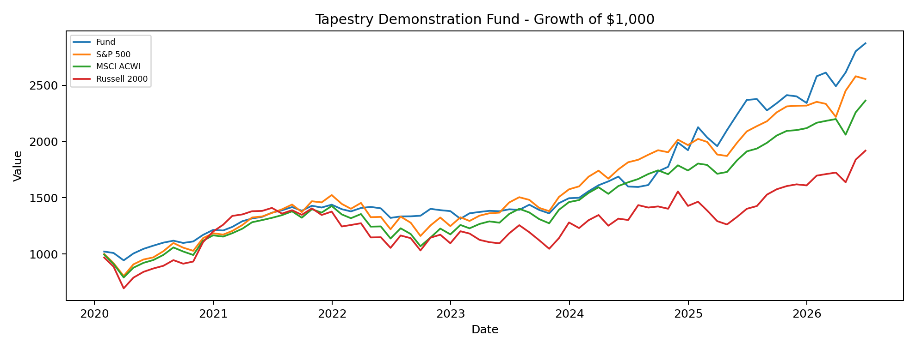
Definition: Shows how an initial $1,000 investment would have compounded over time.
Why It Matters: This is one of the clearest ways to visualize long-term wealth creation and relative compounding versus benchmarks.
Allocator Interpretation: A fund line that compounds above benchmarks may suggest stronger cumulative performance, but investors should review the path of returns and drawdowns alongside the ending value.

Drawdown Comparison
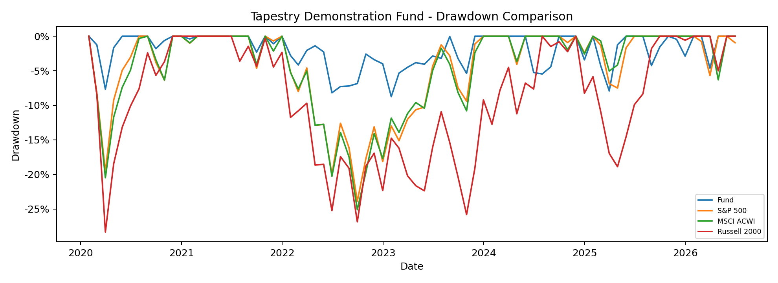
Definition: Shows each return stream’s decline from its prior peak over time.
Why It Matters: Drawdown charts highlight the depth and duration of losses, which are central to allocator risk assessment.
Allocator Interpretation: Shallower or shorter drawdowns versus benchmarks may indicate better capital preservation and downside control.

Rolling 12-Month Returns
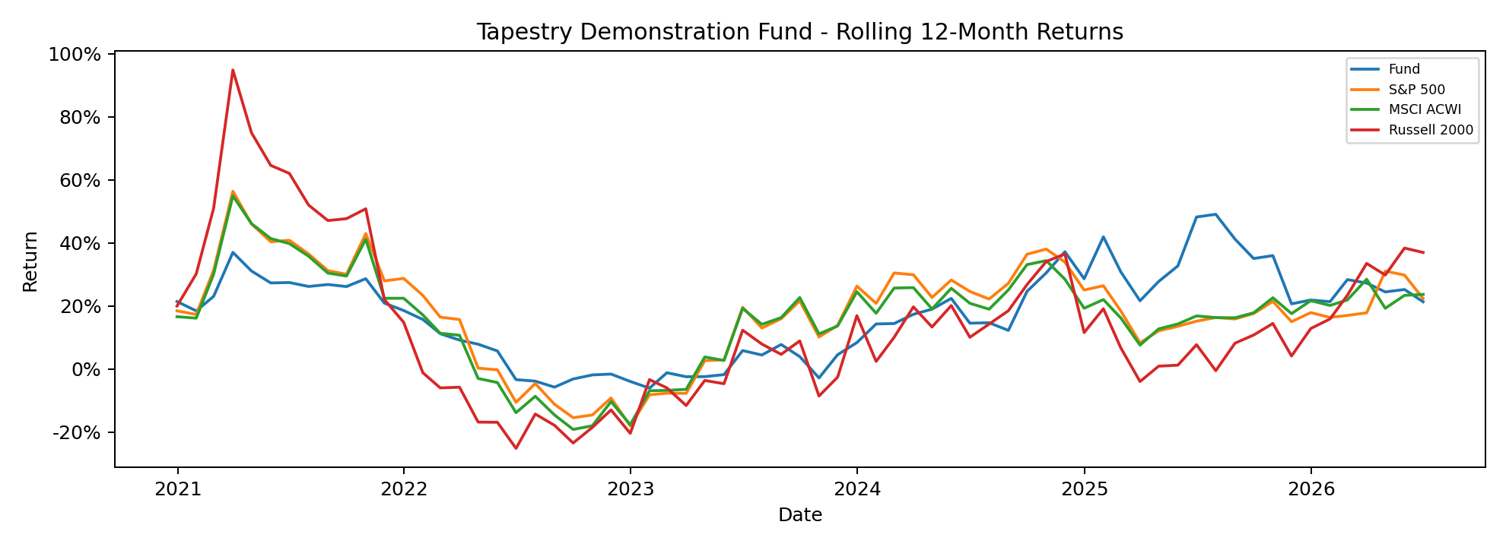
Definition: Shows trailing 12-month returns through time.
Why It Matters: Rolling returns help evaluate whether performance is persistent or concentrated in a few short periods.
Allocator Interpretation: Consistently positive rolling returns relative to benchmarks may indicate durable return generation.

Rolling 12-Month Volatility
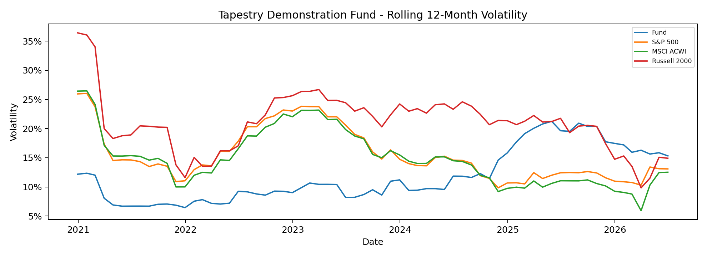
Definition: Shows annualized volatility measured over rolling 12-month windows.
Why It Matters: This helps assess whether the strategy’s risk profile is stable or changing over time.
Allocator Interpretation: Stable or lower rolling volatility relative to benchmarks may indicate disciplined risk management.

Rolling 12-Month Beta
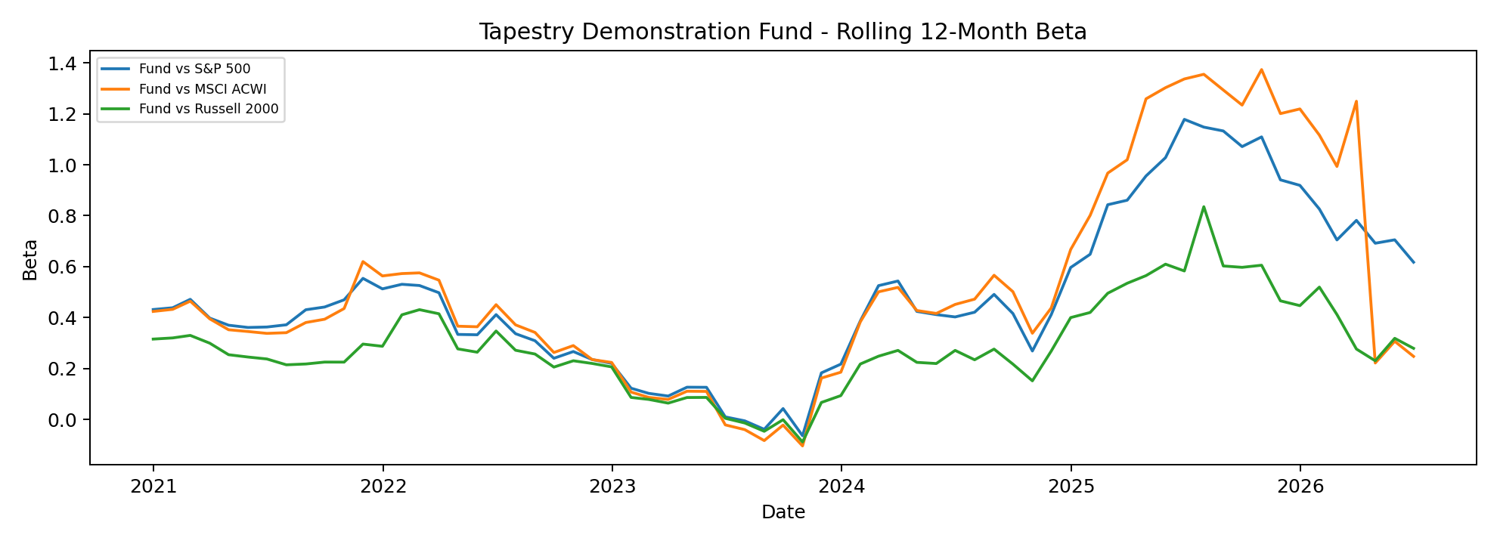
Definition: Shows the Fund’s rolling sensitivity to benchmark returns over trailing 12-month periods.
Why It Matters: Rolling beta helps determine whether market exposure is persistent, changing, or regime-dependent.
Allocator Interpretation: Lower or variable beta may suggest that returns are not purely driven by broad market exposure.

Return Distribution Histogram
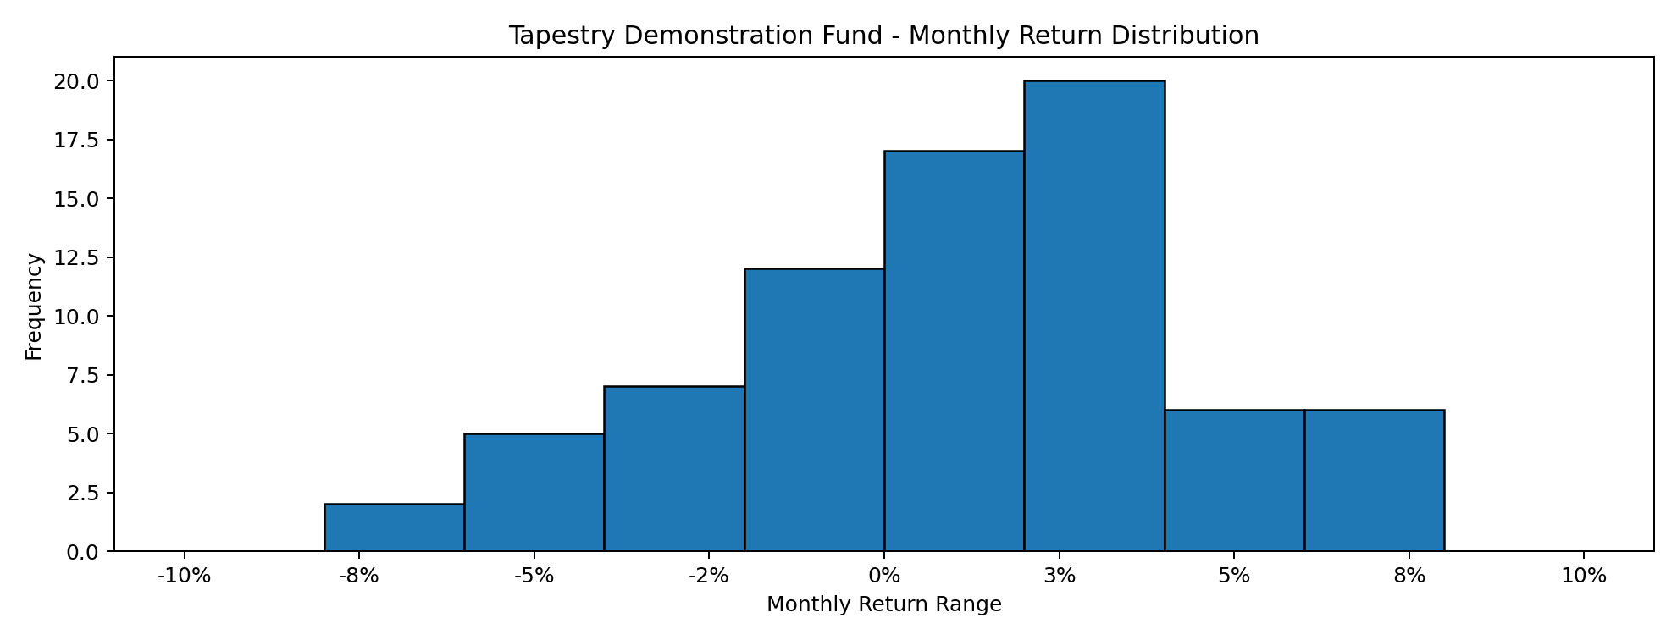
Definition: Shows the frequency of monthly returns across return ranges.
Why It Matters: The histogram helps visualize whether returns are clustered, skewed, or exposed to large outlier events.
Allocator Interpretation: A distribution with more favorable upside than downside observations may support the case for attractive return asymmetry.

Monthly Returns Appendix
Date | Fund | S&P 500 | MSCI ACWI | Russell 2000
Jan-20 | 2.10% | -0.04% | -0.58% | -3.21%
Feb-20 | -1.25% | -8.23% | -8.42% | -8.42%
Mar-20 | -6.50% | -12.35% | -13.17% | -21.73%
Apr-20 | 6.50% | 12.82% | 11.00% | 13.74%
May-20 | 4.10% | 4.76% | 4.90% | 6.51%
Jun-20 | 2.70% | 1.99% | 2.69% | 3.53%
Jul-20 | 2.50% | 5.64% | 4.82% | 2.77%
Aug-20 | 1.60% | 7.19% | 6.73% | 5.63%
Sep-20 | -1.80% | -3.80% | -3.40% | -3.34%
Oct-20 | 1.20% | -2.66% | -3.04% | 2.09%
Nov-20 | 5.25% | 10.95% | 12.83% | 18.42%
Dec-20 | 3.80% | 3.84% | 4.28% | 8.65%
Jan-21 | -0.40% | -1.02% | -0.97% | 5.03%
Feb-21 | 2.60% | 2.76% | 2.60% | 6.23%
Mar-21 | 4.10% | 4.38% | 3.40% | 1.00%
Apr-21 | 1.90% | 5.34% | 4.70% | 2.10%
May-21 | 1.10% | 0.70% | 1.50% | 0.21%
Jun-21 | 2.80% | 2.33% | 1.53% | 1.94%
Jul-21 | 1.50% | 2.38% | 1.82% | -3.61%
Aug-21 | 2.10% | 3.04% | 2.52% | 2.23%
Sep-21 | -2.30% | -4.65% | -4.10% | -2.95%
Oct-21 | 3.20% | 7.01% | 5.69% | 4.25%
Nov-21 | -1.10% | -0.69% | -2.15% | -4.19%
Dec-21 | 1.80% | 4.47% | 4.31% | 2.23%
Jan-22 | -2.80% | -5.17% | -5.27% | -9.63%
Feb-22 | -1.40% | -2.99% | -2.49% | 1.07%
Mar-22 | 2.20% | 3.71% | 2.81% | 1.24%
Apr-22 | 0.68% | -8.72% | -8.27% | -9.91%
May-22 | -0.90% | 0.18% | 0.15% | 0.14%
Jun-22 | -6.05% | -8.26% | -8.63% | -8.23%
Jul-22 | 0.99% | 9.22% | 7.97% | 10.44%
Aug-22 | 0.08% | -4.08% | -4.14% | -2.05%
Sep-22 | 0.38% | -9.22% | -9.24% | -9.57%
Oct-22 | 4.58% | 8.10% | 7.21% | 11.01%
Nov-22 | -0.83% | 5.59% | 7.00% | 2.31%
Dec-22 | -0.62% | -5.77% | -4.21% | -6.49%
Jan-23 | -4.95% | 6.28% | 7.11% | 9.75%
Feb-23 | 3.73% | -2.45% | -2.36% | -1.69%
Mar-23 | 0.89% | 3.66% | 3.18% | -4.78%
Apr-23 | 0.71% | 1.56% | 1.80% | -1.80%
May-23 | -0.25% | 0.43% | -0.92% | -0.93%
Jun-23 | 1.25% | 6.61% | 6.09% | 8.13%
Jul-23 | -0.35% | 3.21% | 3.39% | 6.11%
Aug-23 | 3.27% | -1.59% | -2.34% | -5.01%
Sep-23 | -3.20% | -4.77% | -4.27% | -5.89%
Oct-23 | -2.22% | -2.10% | -2.88% | -6.82%
Nov-23 | 6.69% | 9.13% | 9.43% | 9.03%
Dec-23 | 3.03% | 4.53% | 4.94% | 12.23%
Jan-24 | 0.24% | 1.68% | 1.23% | -3.89%
Feb-24 | 3.85% | 5.34% | 4.28% | 5.65%
Mar-24 | 3.47% | 3.22% | 3.28% | 3.58%
Apr-24 | 2.12% | -4.08% | -3.67% | -7.04%
May-24 | 2.60% | 4.96% | 4.53% | 5.01%
Jun-24 | -5.25% | 3.59% | 2.07% | -0.93%
Jul-24 | -0.23% | 1.22% | 1.79% | 10.16%
Aug-24 | 1.09% | 2.43% | 2.68% | -1.50%
Sep-24 | 7.48% | 2.13% | 1.88% | 0.70%
Oct-24 | 2.39% | -0.92% | -1.96% | -1.44%
Nov-24 | 12.17% | 5.87% | 4.62% | 10.97%
Dec-24 | -3.42% | -2.39% | -2.57% | -8.26%
Jan-25 | 10.62% | 2.78% | 3.55% | 2.62%
Feb-25 | -4.27% | -1.31% | -0.69% | -5.35%
Mar-25 | -3.81% | -5.63% | -4.39% | -6.81%
Apr-25 | 7.26% | -0.68% | 0.93% | -2.31%
May-25 | 6.58% | 6.29% | 5.99% | 5.34%
Jun-25 | 5.83% | 5.08% | 4.35% | 5.43%
Jul-25 | 0.34% | 2.24% | 1.31% | 1.73%
Aug-25 | -4.25% | 2.03% | 2.64% | 7.14%
Sep-25 | 2.80% | 3.64% | 3.26% | 3.11%
Oct-25 | 3.08% | 2.34% | 2.02% | 1.81%
Nov-25 | -0.45% | 0.25% | 0.31% | 0.96%
Dec-25 | -2.45% | 0.06% | 0.84% | -0.58%
Jan-26 | 10.14% | 1.44% | 2.26% | 5.39%
Feb-26 | 1.26% | -0.76% | 0.76% | 0.80%
Mar-26 | -4.63% | -4.98% | 0.76% | 0.80%
Apr-26 | 4.89% | 10.49% | -6.31% | -5.01%
May-26 | 7.23% | 5.26% | 9.64% | 12.29%
Jun-26 | 2.54% | -0.95% | 4.61% | 4.37%
Monthly returns are shown for the Fund and all selected benchmarks included in the source data.
Risk statistics are calculated from monthly returns. For internal analytical use only.

